Name | Method |  | Objective
Constrained-space optimization | DTW  DQL | Surge | 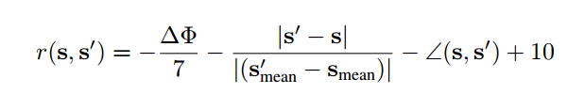  First 2 terms: penalize high joint changes an large displacement  The 3rd therm: penalize actions that results in sharp turn
Learning variable impedance control | PI² | Via-point  Flip a light switch  Open a door | 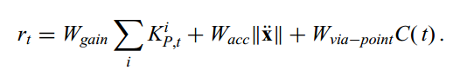
Robot motion skill coordination | PoWER | Reaching task with obstacle avoidance  Pancake-Flipping task | 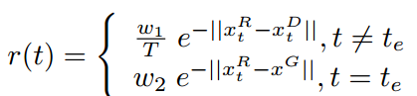  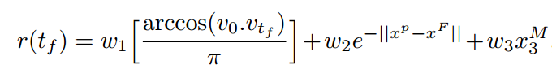
Learning force control | SAC+Force Controller | Peg-insertion | 